Blekos et al., 2024: “A review on Quantum Approximate Optimization Algorithm and its variants”

1) QAOA Ansätze
ma-QAOA (multi-angle):
- One separate angle for every operator in a given layer
- For a given p, better approximation ratio
- Requires shallower circuits
- Can reduce the number of parameters by exploiting symmetries of the problem/graph (Shi et al., 2022)
ADAPT-QAOA (Adaptive Derivative Assembled Problem Tailored):
- Select the QAOA mixer from a pre-defined pool of operators
R-QAOA (Recursive):
- Use the output distribution of QAOA to compute the ZZ -correlations of all pairs of edges in the graph $M_{ij}=<ψ\left|Z_{i}Z_{j}\right|ψ>$
- Select pair with largest magnitude of correlation and impose parity constraint $Z_{j}=sgn\left(M_{ij}\right)Z_{i}$
- Eliminate one or more qubits from the Hamiltonian by imposing a constraint on them
Constrained QAOA:
- In constrained problem, impose penalty on cost Hamiltonian or constrained-preserving mixers
WS-QAOA (warm-Start):
- Use relaxation techniques to initialize the circuit close the optimum
- WS-RQAOA

2) Parameter optimization
Angle initialization:
- Random initial parameters => barren plateau or local minima
- INTERP and FOURIER methods for parameter initialization (Zhou et al.)
Optimizer – gradient-free: COBYLA, Nelder-Mead
Optimizer – gradient-based: Adam, SPSA, BFGS (better in contexts of reduced noise)

3) Overcoming Barren plateaus:
- Barren plateaus = regions where the gradients concerning the trainable parameters vanish exponentially in the number of qubits
- Skolik et al.: layerwise learning strategy
- Circuit depth grown incrementally with only subsets of parameters updated at each step
- Akshay et al.: parameter concentration in QAOA (as an inverse polynomial concerning the problem size)
Zhou et al., 2022: “Quantum Approximate Optimization Algorithm: Performance, Mechanism, and Implementation on Near-Term Devices”

1) Presentation
To compete with the best classical algorithm for some problems on bounded degree graphs, need to go beyond low-depth QAOA
Given the problem, use symmetries to restrict the search space
- Eg for MaxCut: $γ_{i}∈\left[-\frac{π}{2},\frac{π}{2}\right],β_{i}∈\left[-\frac{π}{4},\frac{π}{4}\right]$
Methods
- Gradient-based optimization routine (BFGS): large simulation speed
- Random d-regular graphs

2) Variational parameter optimization techniques
INTERP (interpolation-based): Inductively find the optimal parameters for layer p and produce initial points for p+1 by linear interpolation
FOURIER[q, R]: new representation (u, v) of p-level QAOA parameters
- q = maximum frequency component for amplitude parameters (u, v)
- R = number of random perturbations we add to parameters to escape a local optimum to a better one

3) Comparison between results
Lowest fractional error: FOURIER(∞, 10)
Bayesian optimization worse than Nelder-Mead and BFGS for large p

4) Techniques to speed-up numerical simulations
Use symmetries (eg remain in the positive parity state space)
Directly make use of evolution operators rather than defining the Hamiltonians

Egger et al., 2021: “Warm-starting quantum optimization”

1) Continuous relaxation
See presentation

2) WS-RQAOA
Use correlation matrix to eliminate a decision variable
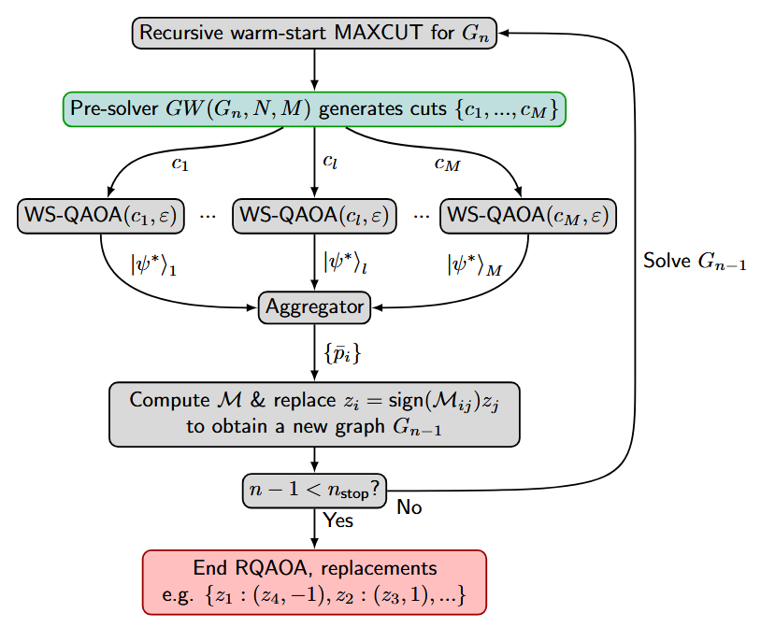

McClean et al., 2018: “Barren plateaus in quantum neural network training landscapes”

1) Barren plateaus
Parametrization AND initial state are important
By Levy’s lemma, the gradient is zero over vast reaches of quantum space
If U_+ or U_- is a unitary 2-design, the variance of measurements will decrease exponentially in the number of qubits
Randomly initialized circuits of sufficient depth will find relatively little utility in hybrid quantum–classical algorithms

2) Solution
Structured initial guesses
Pre-training segment by segment

See Cerezo et al. and Ragone et al.

Grant et al., 2019: “An initialization strategy for addressing barren plateaus in parametrized quantum circuits”

Restrict the effective depth by Block Identity Encoding (see Overleaf)
Other solutions: layer-wise training, regularization, and imposing structural constraints on the ansatz. Understanding more about the relative merits of these and other approaches is a topic for future work.

Liu et al., 2023: “Mitigating Barren Plateaus with Transfer-learning-inspired Parameter Initializations”

Barren plateau: situation when ∇C vanishes exponentially with the number of qubits
- By Tchebyshev, one needs exponential shots to sample the gradient information. Therefore, optimizing parameters in the BP regions with gradient-based methods is difficult.
- Ansatz with strong expressibility has poor trainability
- When BP exits, the probability of finding a set of parameters whose cost function is lower than the average value at a constant c is also exponentially suppressed
- BP equivalent to cost concentration (so gradient-based and gradient-free optimizers are both affected)
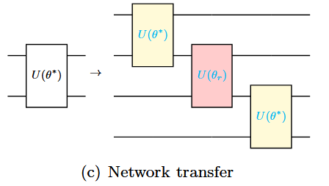
Network transfer: generate a target circuit by simply copying the base circuit (either with optimal or random angle) => for problem-agnostic ansätze

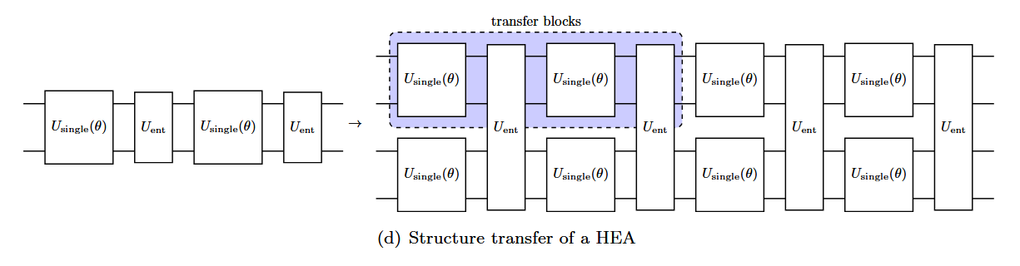
Structure transfer: preserve the structure of the ansatz
BLE to break 2-design structure
- Hard to implement because difficult to compute the rest such that the block compiles to an identity
Layerwise learning
- Grow the ansatz by layers, where mainly newly-added parameters are trained

Skolik et al.: “Layerwise learning for quantum neural networks”

Layerwise learning

